## 1. The Housing (Wales) Act 2014

### Module Content.

1.1 What does the Housing (Wales) Act 2014 (The Act) mean for landlords and agents in Wales?

1.2 What will the legislation achieve?

1.3 What information will be available for the public to view?

1.4 Are there any consequences of not complying with this legislation?

1.5 Landlord registration

1.6 Landlord and agent licensing

1.7 What if the landlord doesn't let and manage the property personally?

1.8 How do I get a licence and what impact will have on me?

1.9 For what letting and management activities does a landlord need a licence?

1.10 For what letting and management activities does an agent need a licence?

1.11 Agent licence additional requirements

1.12 Agent Audit

1.13 I reside outside the UK; can I still let and manage the properties I own in Wales?

1.14 I have a landlord licence, but am going on holiday. Who can manage my property?

1.15 I employ staff to help me manage my property portfolio. Are there any additional requirements?

1.16 I am not the landlord; all I do is check property condition or carry out inventories. Do I need a licence?

1.17 Can I reclaim the cost of the Rent Smart Wales mandatory registration, training and licensing?

## 1. The Housing (Wales) Act 2014

### 1.1 What does the Housing (Wales) Act 2014 (The Act) mean for landlords and agents in Wales?

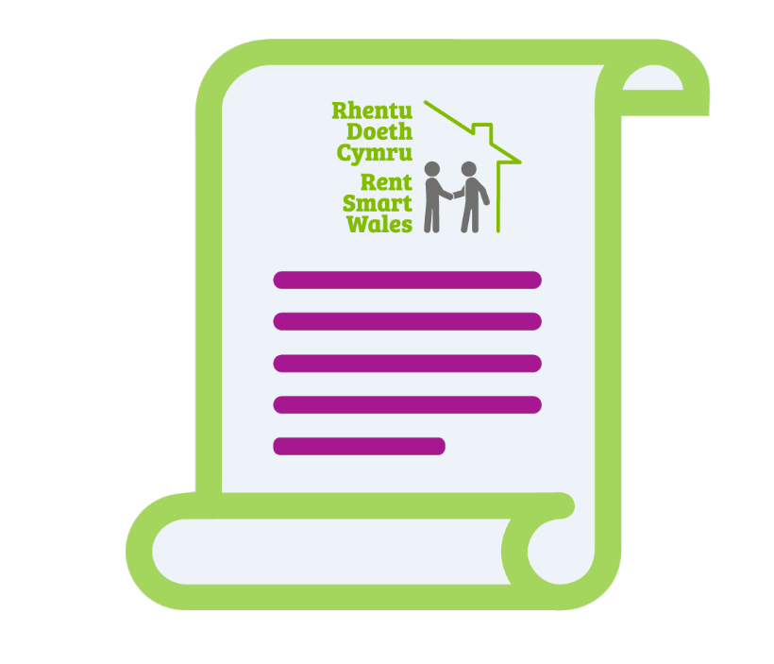Part 1 of the **Housing (Wales)** **Act 2014** requires all landlords who rent out private properties in **Wales** to register with **Rent Smart Wales**. In addition, those agents and managing landlords who undertake the day to day tasks at the rented property need to obtain a licence. Licensing is achieved by undertaking approved training.

The **Housing (Wales) Act 2014** was introduced on the 23 November 2015. The scheme is run and administered by **Rent Smart Wales**.

The introduction of the Housing (Wales) Act 2014 has not repealed any other legislation related to housing. This piece of legislation has introduced new requirements in relation to the rental of private accommodation in Wales.

## 1. The Housing (Wales) Act 2014

### 1.2 What will the legislation achieve?

Improve the supply, quality and standards of letting and management in the **private rented sector.**Provide more information about landlords, agents and the sector which will help tenants and local authorities.  
  
Better awareness by landlords, agents and tenants of their rights and responsibilities.

**1. The Housing (Wales) Act 2014**



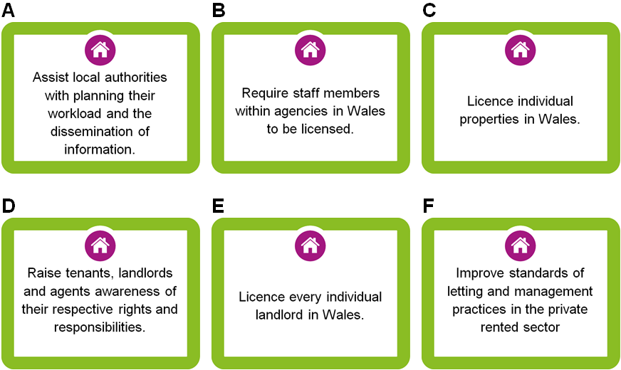

Which of the above statements best describes what The Housing (Wales) Act 2014 will achieve?

* A and C
* C, B and F
* A, D and F
* B, D and E

**1. The Housing (Wales) Act 2014**

**1.3 What information will be available to the public?**

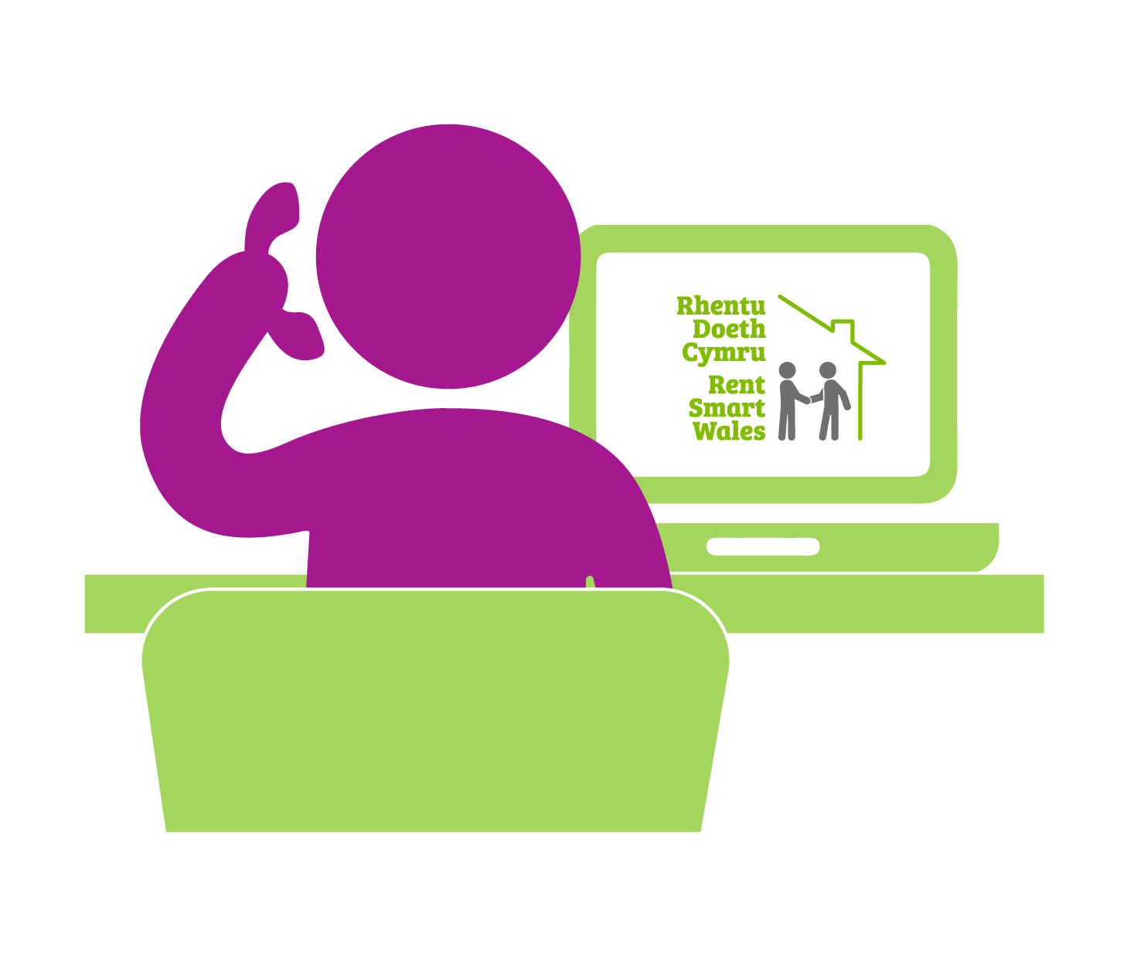

**Rent Smart Wales**will establish a comprehensive, central database of all private landlords and agents that operate in **Wales**. Some limited information will be publicly available online.

A search functionality will be available on the website in order to:

* **Verify that a landlord and property are registered;**
* Verify that the person **undertaking the letting and management of a rental property is licensed.**

## 1. The Housing (Wales) Act 2014

### 1.4 Are there any consequences to not complying with this legislation?

Enforcement powers became effective on the **23 November 2016**.

These powers include a range of penalties that can be enforced either by the licensing authority or a local authority.

**Non-compliance could result in:**

                                             Rent Repayment Orders,

                                             Fixed Penalty Notices,

                                             Rent Stopping Orders and

                                             Summary convictions (with fines).

Click the images below to find out more about the enforcement powers:

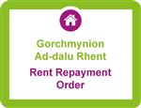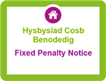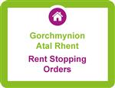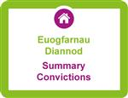

### A rent repayment order is made by a Residential Property Tribunal.  It requires the appropriate person (usually the landlord) to pay to the applicant (usually the tenant) an amount of money which will be specified in the order.



### The fixed penalty under this Act is £150 or £250. This notice is used when an offence has been committed, in place of court proceedings.



### A rent stopping order has the effect of stopping those rent/service charge payments (or parts of payments) owed by a tenant to their landlord for a specified period (until the offence stops being committed).



### A summary offence is an offence which is triable in court. Different levels of fines can be applied to a summary offence depending on the seriousness of the offence.

## 1. The Housing (Wales) Act 2014

### 1.5 Landlord Registration

A landlord must register their personal details and the addresses of their rental properties in Wales. Once registered they must keep the information on the register up to date. **The Housing (Wales) Act 2014**only applies to assured, assured shorthold and regulated tenancies (usually known as domestic tenancies). Other types of tenancies such as commercial and agricultural are regulated by other housing legislation.   
  
A different registration has to be set up for each type of landlord arrangement.

**What does this mean?**This means that if you are the landlord for one property you need to register that property under your name and pay the respective registration fee. If you are also a joint landlord for a second property, you need to register this property under a different registration. You will need to pay a separate fee for this second registration.

Therefore, you are part of two different landlord arrangements and will have to complete two separate registrations. In the event of you owning a third property in the name of a company (meaning the company is the landlord), this is considered a different landlord arrangement and a new registration needs to be completed and so forth.  
  
If you not sure about your landlord arrangements and the number of registrations you need to complete, just contact **Rent Smart Wales**.

**1. The Housing (Wales) Act 2014**

**1.5 Landlord Registration.**

**Landlords must notify the Licensing Authority of a change to:**

* Name;
* Address;
* Other contact details;
* Rented property addresses;
* Letting and Management arrangements for each rental property.

**This is quick and easy to do on-line.**

Landlords have 28 days to inform the **Licensing Authority**of any changes to their registration details. Where a property is owned jointly one owner can nominate themselves as the “lead landlord” and complete the registration. However, all landlords need to be named on the registration.



**All owners need to be named on the registration.**

The registration can be either completed online or by a paper application form. A fee must be paid. You can download a landlord paper registration form [**here**](https://www.rentsmart.gov.wales/Uploads/Downloads/00/00/00/05/DownloadFileEN_FILE/REGISTRATION-FORM.pdf).



The registration is valid for **five years.**

**1.5 Landlord Registration.**



If you own the property jointly, who needs to be named on the registration?

* Only the lead landlord needs to be named on the registration.
* A joint registration is done detailing all owners.

## 1. The Housing (Wales) Act 2014

### 1.6 Landlord and Agent Licensing.

If a landlord or agent undertakes any letting or property management activities at a rental property in Wales they must obtain a licence from**Rent Smart Wales**. Once licensed, a licence holder must keep the information held by the licensing authority up to date. A licence holder is required to notify the authority should their contact details or circumstances change. **This is quick and easy to do in their on-line account.**

If you are both a landlord and an agent, you only need to apply for an agent licence and complete agent training. The licence will cover you for both landlord and agent activities.

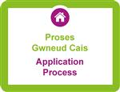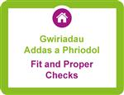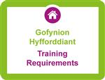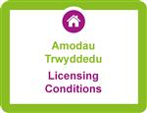

### Your application can be completed online or by paper. This will involve giving your correspondence address, details of any staff you employ, details of your training and declare yourself to be a fit and proper person.



### As part of the application process, you must declare yourself ‘fit and proper.’ This involves declaring any criminal convictions or other offences. A full list is provided on the application form.



### Under The Act, anyone who wishes to have a licence must be trained. The training can either be undertaken in the classroom or online. Further details can be found on the My Bookings / Training section of your Dashboard.



### Once your licence has been submitted, it will be reviewed. If successful, Rent Smart Wales will attach conditions. These could either be standard and/or bespoke conditions for your particular circumstances.

### Failure to comply with these conditions could lead to your licence being revoked.

## 1. The Housing (Wales) Act 2014

### 1.7 What if the landlord doesn't let and manage the property personally?

If a landlord asks an agent to do letting and management work on their behalf, it is their **agent who must become licensed**. In some instances where management work is shared, both landlord and agent will need to be licensed.

You are an Agent if you undertake work (specified in section 10 and 12 of the Act) on behalf of a landlord. You do not need to be a commercial agent to fall into the category. For example, you could be looking after your relatives' property. In this case you would need an Agent Licence.

## 1. The Housing (Wales) Act 2014

### 1.8 How do I get a licence and what impact will it have on me?

To get a licence you must be adequately trained, and also declare yourself to be ‘fit and proper’; a term defined in law.   
  
There will be conditions attached to your licence. As a minimum, you must comply with a Welsh Minister approved **Code of Practice** containing letting and management standards for rental properties. You can access the Code [**here**](https://www.rentsmart.gov.wales/Uploads/Downloads/00/00/00/01/DownloadFileEN_FILE/Code-of-practice-for-Landlords-and-Agents-licensed-under-Part-1-of-the-Housing-Wales-Act-2014-English-Doc-1.pdf).  
  
Licences can be revoked if a licence holder breaches a licence condition or is no longer ‘fit and proper’. The licence application can be either completed online or by paper application. A fee must be paid. You can download an agent licence paper application [**here**](https://www.rentsmart.gov.wales/Uploads/Downloads/00/00/00/07/DownloadFileEN_FILE/AGENT-LICENCE-FORM.pdf). For information on fees please consult the [**Rent Smart Wales Fee Companion.**](https://www.rentsmart.gov.wales/Uploads/Downloads/00/00/00/14/DownloadFileEN_FILE/Rent-Smart-Wales-Fee-Policy-E-.pdf)



The licence is valid for **five years**, after which time it must be renewed and a further fee paid.



It is strongly recommended that a licence holder applies for renewal in advance of expiry. A licence holder can apply for renewal during the period of 84 days before the expiry date.

**1. The Housing (Wales) Act 2014**

**1.9 For what letting and management activities does a landlord need a licence?**

A landlord doing **any of the following** will need a licence:

**Landlord Letting Activities:**

* Arranging or conducting viewings with prospective tenants;
* Gathering evidence for the purpose of establishing the suitability of prospective tenants (for example, by confirming character references, undertaking credit checks or interviewing a prospective tenant);
* Preparing, or arranging the preparation, of a tenancy agreement;
* Preparing, or arranging the preparation, of an inventory for the dwelling or schedule of condition for the dwelling.

**1.9 For what letting and management activities does a landlord need a licence?**

A landlord doing **any of the following**will need a licence:

**Landlord Property Management Activities:**

* Collecting rent;
* Being the principal point of contact for the tenant in relation to matters arising under the tenancy;
* Making arrangements with a person to carry out repairs or maintenance;
* Making arrangements with a tenant or occupier of the dwelling to secure access to the dwelling for any purpose;
* Checking the contents or condition of the dwelling, or arranging for them to be checked as part of a current tenancy or for one which has ended;
* Serving notice to terminate a tenancy.

**1. The Housing (Wales) Act 2014**

**1.10 For what letting and management activities does an agent need a licence?**

**Agent Letting Work:**

One of these can be done by a person who is not the landlord without requiring an agent licence, as long they do nothing under the ‘agent property management work’ section.

* Publishing advertisements or disseminating information;
* Arranging and conducting viewings with prospective tenants;
* Preparing, or arranging the preparation of, the tenancy agreement;
* Preparing, or arranging the preparation of, any inventory or schedule of condition.

## 1. The Housing (Wales) Act 2014

**1.10 For what letting and management activities does an agent need a licence?**

**Agent Property Management Work:**

* **Collecting rent, on its own, requires a licence.**

It is acceptable to do one of the following without requiring a licence, as long as you do not collect rent, or do anything under the ‘Agent Letting Work’ section.

* Being the principal point of contact for the tenant in relation to matters arising under the tenancy;
* Making arrangements with a person to carry out repairs or maintenance;
* Making arrangements with a tenant or occupier of the dwelling to secure access to the dwelling for any purpose;
* Checking the contents or condition of the dwelling, or arranging for them to be checked as part of a current tenancy or for one that has ended;
* Serving notice to terminate a tenancy.

**1. The Housing (Wales) Act 2014**

**1.10 For what letting and management activities does an agent need a licence?**

**Agent Property Management Work:**

* **Collecting rent, on its own, requires a licence.**

It is acceptable to do one of the following without requiring a licence, as long as you do not collect rent, or do anything under the ‘Agent Letting Work’ section.

* Being the principal point of contact for the tenant in relation to matters arising under the tenancy;
* Making arrangements with a person to carry out repairs or maintenance;
* Making arrangements with a tenant or occupier of the dwelling to secure access to the dwelling for any purpose;
* Checking the contents or condition of the dwelling, or arranging for them to be checked as part of a current tenancy or for one that has ended;
* Serving notice to terminate a tenancy.

## 1. The Housing (Wales) Act 2014

### 1.12 Agent Audit

**Agent Audit**

Rent Smart Wales (the Licensing Authority) has established an Agent Audit process as part of the compliance monitoring process.

The Agent Audit process aims to gain assurance the Licence Holder is operating to a high standard to maintain Rent Smart Wales Licensed Agent status.

The scope of the audit will include measuring the Licence Holder’s capability and performance in respect of their compliance with their licence conditions, the Rent Smart Wales Code of Practice and legislative requirements.

Any legislative requirements that are not met or offences identified during the audit will be referred to the relevant enforcing organisations e.g. Trading Standards, Environmental Health, HSE, along with the Agents details.

Failure to engage with the RSW Agent Audit process may result in your Agent Licence being revoked**.**

 

## 1. The Housing (Wales) Act 2014

### 1.13 I reside outside the UK; can I still let and manage the properties I own in Wales?

Landlords who live outside of England, Scotland and Wales or more than 200 miles from their rental property are required to appoint a local* agent unless they have a locally based* staff member, formally employed on a contract of service.

Appointing an agent does not preclude the landlord from also holding a licence if they wish to also carry out letting and management activities.

Your licensed agent can be a high street letting and management agency, or an individual such as a family member or friend as long as they obtain a licence from Rent Smart Wales. However they are required to be local* to the property i.e. reside in England, Scotland or Wales and within 200 miles of the rental property.

If your licensed agent is a family member (As defined by the Housing Act 2004 -Mother, Father, Brother, Sister, Aunt, Uncle, Grandfather, Grandmother, step-relatives and relatives-by-law) they will pay the landlord licence application fee.

**Please note that appointing an unlicensed agent is an offence.** Click [**here**](https://www.rentsmart.gov.wales/en/check-register/)to access the Public Register to check if an agent is licensed with Rent Smart Wales.

Rent Smart Wales can issue your landlord licence before you appoint a local* agent or employee, but your licence will have a condition on it specifying that you must appoint a licensed local* agent or employ a locally* based member of staff to assist in the management of the rental properties within 8 weeks of the licence being granted.

*locally based / local means somebody who lives in England, Scotland or Wales and is within 200 miles (i.e. less than) of the rental property.

** the mileage calculated through the use of Google maps using the shortest distance calculator between the landlord’s home address or the agents business address and the rental property at the furthest distance.

## 1. The Housing (Wales) Act 2014

### 1.14 I have a landlord licence, but am going on holiday. Who can manage my property?

You may appoint an unlicensed person to be the main point of contact and make any decisions relating to your rented properties in an emergency or in the following circumstances:  
  
For a short period of time, no more than **4 consecutive weeks in any 12 month period**, such as a holiday or hospital stay.  
  
If you are outside of mainland Britain/unable to manage your property(s) for more than 4 consecutive weeks you must appoint a mainland Britain-based licensed agent to let and manage your properties on your behalf for this time period

## 1. The Housing (Wales) Act 2014

### 1.15 I employ staff to help me manage my property portfolio. Are there any additional requirements?

**The legal definition of a “connected person” is:**

‘a person doing things under a contract of service or apprenticeship with an applicant for a licence where the applicant for a licence is the landlord and the person does any of the things listed in: (i) section 6(2) (requirement for landlords to be licensed to carry out lettings activities) of the Act; and (ii) section 7(2) (requirement for landlords to be licensed to carry out property management activities) of the Act’

**Generally, a person under a contract of service is a salaried staff member.**   
  
People you pay for the services they provide (e.g. contractors) or people you instruct to act on your behalf are not counted as ‘connected persons’ and they do not have to be trained in order for the landlord to obtain a licence.

### 1.16 I am not the landlord; all I do is check property condition or carry out inventories. Do I need a licence?

No. If the **only thing** you do either before, during or after a tenancy is create an inventory or schedule of condition **you do not need to be licensed as an agent**(unless you do another of the listed items).

**1. The Housing (Wales) Act 2014**



True or false: You do not need a licence if you only collect rent?

* True
* False

## 1. The Housing (Wales) Act 2014

### 1.17 Can I reclaim the costs of the Rent Smart Wales mandatory registration, training and licensing?

You can [**deduct these costs in arriving at your taxable profits**](https://www.gov.uk/tax-relief-for-employees/how-to-claim?utm_source=rentsmartwales&utm_medium=FAQ&utm_campaign=hmrc-let-property-sept15) on the training, registration and licence costs you have paid, as it relates to a mandatory requirement for all landlords or agents who manage properties in Wales.

If you were one of the people who paid for your fees between November 2015 and 5th April 2016, it can be claimed as an expense on your 2015-16 tax return. Payments made between 6th April 2016 and 5th April 2017 can be included on your 2016-17 tax return. If any further registration, training and licence is undertaken, the costs will be deductible in the relevant tax year.

Please click on the link below if you would like to complete the HMRC online guide "**Letting out Property**". This guide provides information on the following topics: My property income, what do I need to do for HMRC, working out my profit or loss, expenses, and what happens when I stop letting out a property or sell it? This guide is useful if you have income from property for the first time and aren't sure where to start, this is for you. However, experienced landlords, letting agents and others may also find this useful.

[**http://www.hmrc.gov.uk/courses/syob3/new_letting/HTML/new_letting_menu.html**](http://www.hmrc.gov.uk/courses/syob3/new_letting/HTML/new_letting_menu.html)